VISVESVARAYA TECHNOLOGICAL UNIVERSITY
“JnanaSangama”, Belgaum -590014, Karnataka.

LAB REPORT
On
ANALYSIS AND DESIGN OF ALGORITHMS (23CS4PCADA)
Submitted by
SHRIHARI VISWANATHAN (1BF24CS288)
in partial fulfillment for the award of the degree of
BACHELOR OF ENGINEERING
in
COMPUTER SCIENCE AND ENGINEERING

B.M.S. COLLEGE OF ENGINEERING
(Autonomous Institution under VTU)
BENGALURU-560019
February to June 2026
CERTIFICATE
B. M. S. College of Engineering,
Bull Temple Road, Bangalore 560019
(Affiliated To Visvesvaraya Technological University, Belgaum) Department of Computer Science and Engineering

This is to certify that the Lab work entitled “ANALYSIS AND DESIGN OF ALGORITHMS” carried out by SHRIHARI VISWANATHAN (1BF24CS288), who is bonafide student of B. M. S. College of Engineering. It is in partial fulfillment for the award of Bachelor of Engineering in Computer Science and Engineering of the Visvesvaraya Technological University, Belgaum during the year 2025-26. The Lab report has been approved as it satisfies the academic requirements in respect of Analysis and Design of Algorithms Lab - (23CS4PCADA) work prescribed for the said degree.
Dr. Rajeswari B S Dr. Kavitha Sooda
Professor Professor and Head
Department of CSE Department of CSE
BMSCE, Bengaluru BMSCE, Bengaluru

Index Sheet
Sl.  No. | Experiment Title | Page No.
1 | Lab program 1: | 5
2 | Lab Program 2: Leetcode exercises on DFS, BFS | 9
3 | Lab Program 3: Leetcode exercises on Trees and Graphs | 9
4 | Lab Program 4: Write program to obtain the Topological ordering of vertices in a given digraph. | 13
5 | Lab Program 5: Implement Johnson Trotter algorithm to generate permutations. | 15
6 | Lab Program 6: Sort a given set of N integer elements using Merge Sort technique and compute its time taken. Run the program for different values of N and record the time taken to sort. | 17
7 | Lab Program 7: Sort a given set of N integer elements using Quick Sort technique and compute its time taken. | 19
8 | Lab Program 8: Sort a given set of N integer elements using Heap Sort technique and compute its time taken. | 21
9 | Lab Program 9: | 23
10 | Lab Program 10: | 27
11 | Lab Program 11: | 31
12 | Lab Program 12: Implement fractional knapsack problem using Greedy technique. | 35
13 | Lab Program 13: From a given vertex in a weighted connected graph, find shortest paths to other vertices using Dijkstra’s algorithm. | 37
14 | LAB PROGRAM 14:

Course outcomes:
CO1 | Analyze time complexity of algorithms using asymptotic notations.
CO2 | Apply various algorithm design techniques for the given problem.
CO3 | Evaluate the appropriate algorithm/design technique for solving a given problem.
CO4 | Conduct practical experiments by applying appropriate algorithm design technique to solve problems.

Lab program 1:

LEETCODE: 3029. Minimum Time to Revert Word to Initial State I

Code:

// Comparator for sorting
int cmp(const void* a, const void* b) {
return *(char*)a - *(char*)b;
}

char* orderlyQueue(char* s, int k) {
int n = strlen(s);

// Case 1: k > 1, we can generate any permutation → just sort
if (k > 1) {
qsort(s, n, 1, cmp);
return s;
}

// Case 2: k == 1 → find lexicographically smallest rotation (Booth's algorithm)
int i = 0, j = 1, k2 = 0;

while (i < n && j < n && k2 < n) {
char a = s[(i + k2) % n];
char b = s[(j + k2) % n];

if (a == b) {
k2++;
} else {
if (a > b)
i = i + k2 + 1;
else
j = j + k2 + 1;

if (i == j)
j++;
k2 = 0;
}
}

int start = i < j ? i : j;

// Build the resulting smallest rotation
char* res = malloc(n + 1);
for (int t = 0; t < n; t++) {
res[t] = s[(start + t) % n];
}
res[n] = '\0';

return res;
}

OUTPUT:



LEETCODE: 899 Orderly Queue

Code
// Comparator for sorting
int cmp(const void* a, const void* b) {
return *(char*)a - *(char*)b;
}

char* orderlyQueue(char* s, int k) {
int n = strlen(s);

// Case 1: k > 1, we can generate any permutation → just sort
if (k > 1) {
qsort(s, n, 1, cmp);
return s;
}

// Case 2: k == 1 → find lexicographically smallest rotation (Booth's algorithm)
int i = 0, j = 1, k2 = 0;

while (i < n && j < n && k2 < n) {
char a = s[(i + k2) % n];
char b = s[(j + k2) % n];

if (a == b) {
k2++;
} else {
if (a > b)
i = i + k2 + 1;
else
j = j + k2 + 1;

if (i == j)
j++;

k2 = 0;
}
}

int start = i < j ? i : j;

// Build the resulting smallest rotation
char* res = malloc(n + 1);
for (int t = 0; t < n; t++) {
res[t] = s[(start + t) % n];
}
res[n] = '\0';

return res;
}

Output:


Lab Program 2: Leetcode exercises on DFS, BFS

Lab Program 3: Leetcode exercises on Trees and Graphs

LEETCODE: 329 Longest Increasing Path in a Matrix

Code:
int dfs(int** matrix, int rows, int cols, int i, int j, int** dp) {
if (dp[i][j] != 0)
return dp[i][j];

int dirs[4][2] = {{1,0},{-1,0},{0,1},{0,-1}};
int maxLen = 1;

for (int d = 0; d < 4; d++) {
int ni = i + dirs[d][0];
int nj = j + dirs[d][1];

if (ni >= 0 && ni < rows && nj >= 0 && nj < cols &&
matrix[ni][nj] > matrix[i][j]) {

int len = 1 + dfs(matrix, rows, cols, ni, nj, dp);
if (len > maxLen)
maxLen = len;
}
}

dp[i][j] = maxLen;
return maxLen;
}

int longestIncreasingPath(int** matrix, int matrixSize, int* matrixColSize) {

if (matrixSize == 0) return 0;

int rows = matrixSize;
int cols = matrixColSize[0];

int** dp = (int**)malloc(rows * sizeof(int*));
for (int i = 0; i < rows; i++) {
dp[i] = (int*)calloc(cols, sizeof(int));
}

int result = 0;

for (int i = 0; i < rows; i++) {
for (int j = 0; j < cols; j++) {

int len = dfs(matrix, rows, cols, i, j, dp);
if (len > result)
result = len;
}
}

for (int i = 0; i < rows; i++)
free(dp[i]);
free(dp);

return result;
}

Output:
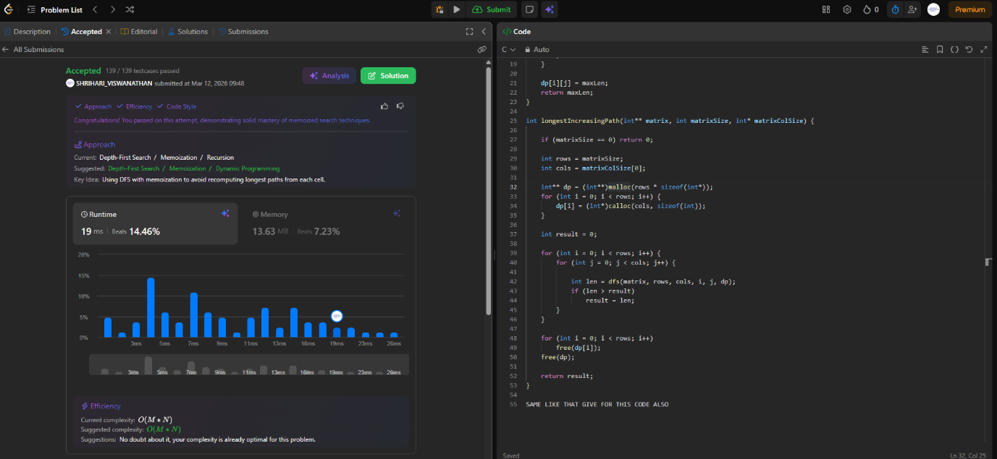

LEETCODE: 753 Cracking The Safe

Code
void dfs(int node, int k, int mod, int *visited, char *result, int *idx) {
for (int i = 0; i < k; i++) {
int edge = node * k + i;

if (!visited[edge]) {
visited[edge] = 1;

int next = edge % mod;

dfs(next, k, mod, visited, result, idx);

result[(*idx)++] = '0' + i;
}
}
}

char* crackSafe(int n, int k) {
int totalEdges = pow(k, n);
int mod = pow(k, n - 1);

int *visited = calloc(totalEdges, sizeof(int));

char *result = malloc(totalEdges + n);
int idx = 0;

dfs(0, k, mod, visited, result, &idx);

for (int i = 0; i < n - 1; i++)
result[idx++] = '0';

result[idx] = '\0';

free(visited);
return result;
}

Output:
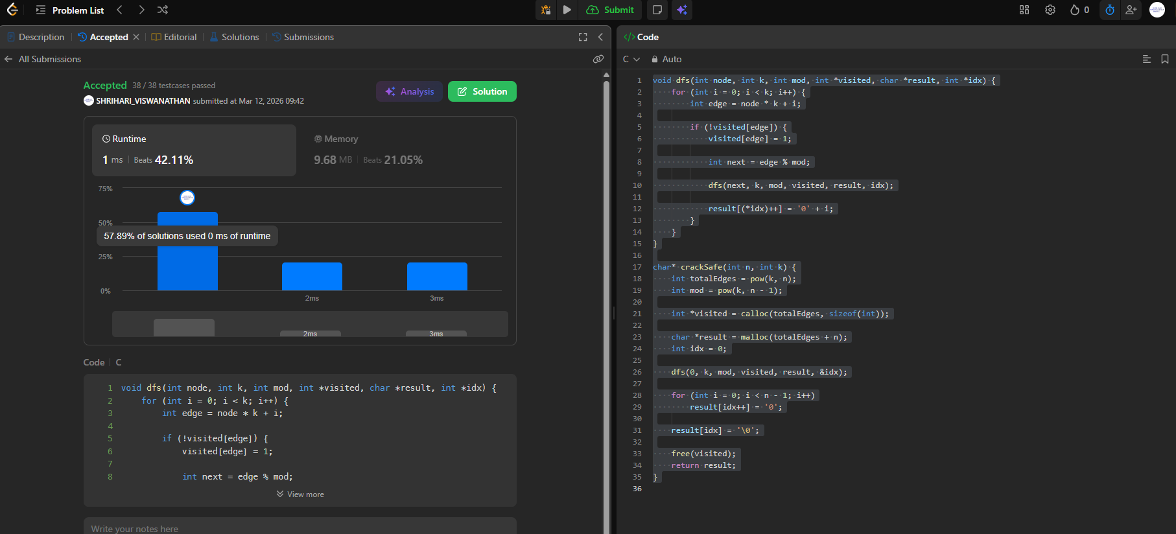

Lab Program 4: Write program to obtain the Topological ordering of vertices in a given digraph.

Code:
#include <stdio.h>

#define INF 9999

int main() {
int n;

printf("Enter no. of vertices: ");
scanf("%d", &n);

int cost[n][n], dist[n], visited[n];

printf("Enter cost adjacency matrix:\n");
for (int i = 0; i < n; i++) {
for (int j = 0; j < n; j++) {
scanf("%d", &cost[i][j]);
if (cost[i][j] == 0 && i != j) {
cost[i][j] = INF;
}
}
}

int source;
printf("Enter Source vertex: ");
scanf("%d", &source);

// Initialization
for (int i = 0; i < n; i++) {
dist[i] = cost[source][i];
visited[i] = 0;
}

dist[source] = 0;
visited[source] = 1;

// Main Dijkstra's Algorithm loop
for (int count = 1; count < n; count++) {
int min = INF;
int next = -1;

// Find the unvisited vertex with the minimum distance
for (int i = 0; i < n; i++) {
if (!visited[i] && dist[i] < min) {
min = dist[i];
next = i;
}
}

// Mark the selected vertex as visited (Added to fix the logic)
if (next != -1) {
visited[next] = 1;

// Update the distance of the neighboring vertices
for (int i = 0; i < n; i++) {
if (!visited[i] && (min + cost[next][i] < dist[i])) {
dist[i] = min + cost[next][i];
}
}
}
}

// Printing the output
printf("\nShortest distance from source\n");
for (int i = 0; i < n; i++) {
printf("%d -> %d = %d\n", source, i, dist[i]);
}

return 0;
}

Output:
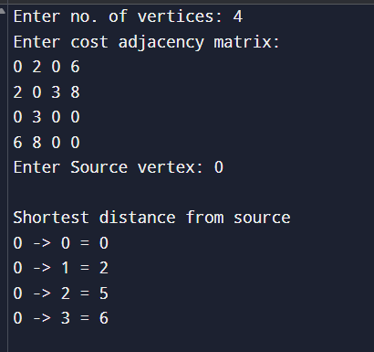

Lab Program 5: Implement Johnson Trotter algorithm to generate permutations.

Code:
#include <stdio.h>
#include <stdbool.h>

typedef struct {
int val;
bool dir; // false = left, true = right
} Node;

// Function to swap two nodes
void Swap(Node *a, Node *b) {
Node temp = *a;
*a = *b;
*b = temp;
}

// Function to print the current permutation
void PrintPermutation(Node a[], int n) {
for (int i = 0; i < n; i++) {
printf("%d ", a[i].val);
}
printf("\n");
}

int main() {
int n;
printf("Enter n: ");
if (scanf("%d", &n) != 1 || n < 1) return 1;

Node a[n];

// Initialize elements from 1 to n with a left-facing direction
for (int i = 0; i < n; i++) {
a[i].val = i + 1;
a[i].dir = false;
}

printf("\nPermutations:\n");
PrintPermutation(a, n);

while (true) {
int mobile_index = -1;
int max_mobile = -1;

// Find the largest mobile element
for (int i = 0; i < n; i++) {
// Direction is LEFT
if (!a[i].dir && i > 0 && a[i].val > a[i - 1].val) {
if (a[i].val > max_mobile) {
max_mobile = a[i].val;
mobile_index = i;
}
}
// Direction is RIGHT
else if (a[i].dir && i < n - 1 && a[i].val > a[i + 1].val) {
if (a[i].val > max_mobile) {
max_mobile = a[i].val;
mobile_index = i;
}
}
}

// If no mobile element is found, all permutations have been generated
if (mobile_index == -1) break;

// Swap the mobile element with the element it is pointing to
if (!a[mobile_index].dir) {
Swap(&a[mobile_index], &a[mobile_index - 1]);
} else {
Swap(&a[mobile_index], &a[mobile_index + 1]);
}

// Reverse the direction of all elements greater than the chosen mobile element
for (int i = 0; i < n; i++) {
if (a[i].val > max_mobile) {
a[i].dir = !a[i].dir;
}
}

PrintPermutation(a, n);
}

return 0;
}

Output:
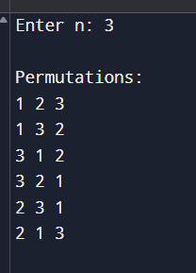

Lab Program 6: Sort a given set of N integer elements using Merge Sort technique and compute its time taken. Run the program for different values of N and record the time taken to sort.

Code:
#include<stdio.h>

void merge(int s, int m, int e, int arr[]){
int i = s;
int j = m+1;
int k = 0;
int final[e-s+1];

while(i <= m && j <= e){

if (arr[i] <= arr[j]){
final[k] = arr[i];
i++;
}

else {
final[k] = arr[j];
j++;
}

k++;
}

while (i <= m){
final[k] = arr[i];
i++;
k++;
}

while (j <= e){
final[k] = arr[j];
j++;
k++;
}

for(int i = s; i <= e; i++){
arr[i] = final[i - s];
}

}

void merge_sort(int start, int end, int arr[]){
if (start == end) {
int *res = malloc(sizeof(int));
res[0] = arr[start];
return;
}
int mid = (start + end) / (int) 2;
merge_sort(start, mid, arr);
merge_sort(mid+1, end, arr);
merge(start, mid, end, arr);
}

int main(){
int n;
printf("No.of elements: ");
scanf("%d", &n);

int arr[n];

printf("Enter %d elements: ", n);
for(int i = 0; i < n; i++){
scanf("%d", &arr[i]);
}

merge_sort(0, n, arr);

for (int i = 0; i < n; i++){
printf("%d\n", arr[i]);
}
}

Output:
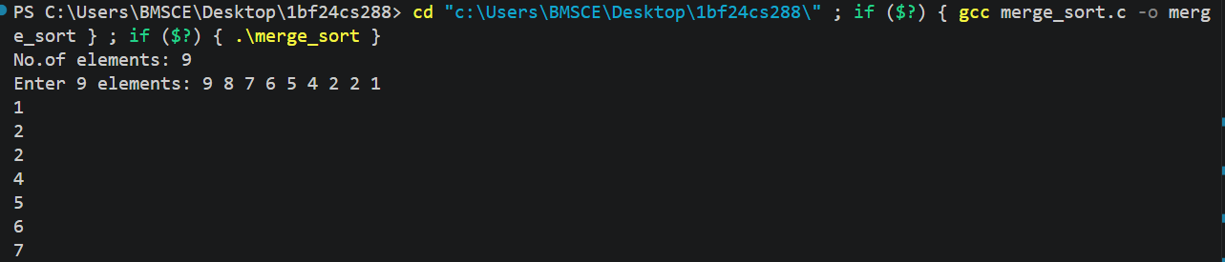

Graph:
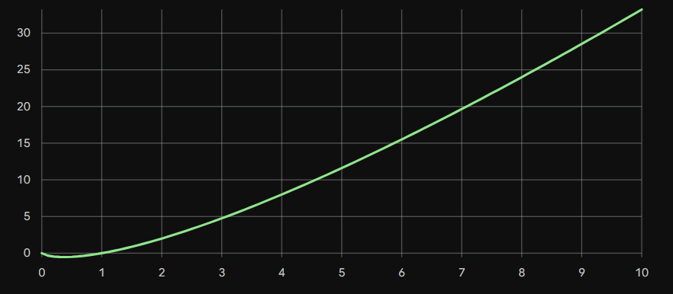

Lab Program 7: Sort a given set of N integer elements using Quick Sort technique and compute its time taken.

Code:
#include <stdio.h>

int partition(int arr[], int low, int high) {
int pivot = arr[low]; // choose first element as pivot
int i = low + 1;
int j = high;

while (1) {
while (i <= high && arr[i] <= pivot)
i++;

while (arr[j] > pivot)
j--;

if (i >= j)
break;

// swap arr[i] and arr[j]
int temp = arr[i];
arr[i] = arr[j];
arr[j] = temp;
}

// place pivot in correct position
int temp = arr[low];
arr[low] = arr[j];
arr[j] = temp;

return j;
}

void quick_sort(int arr[], int low, int high) {
if (low < high) {
int p = partition(arr, low, high);

quick_sort(arr, low, p - 1);
quick_sort(arr, p + 1, high);
}
}

int main() {
int n;

printf("Enter number of elements: ");
scanf("%d", &n);

int arr[n];

printf("Enter elements:\n");
for (int i = 0; i < n; i++) {
scanf("%d", &arr[i]);
}

quick_sort(arr, 0, n - 1);

printf("Sorted array:\n");
for (int i = 0; i < n; i++) {
printf("%d ", arr[i]);
}

return 0;
}

Output:
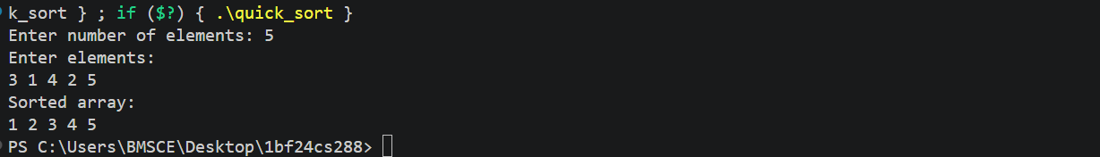

Graph:
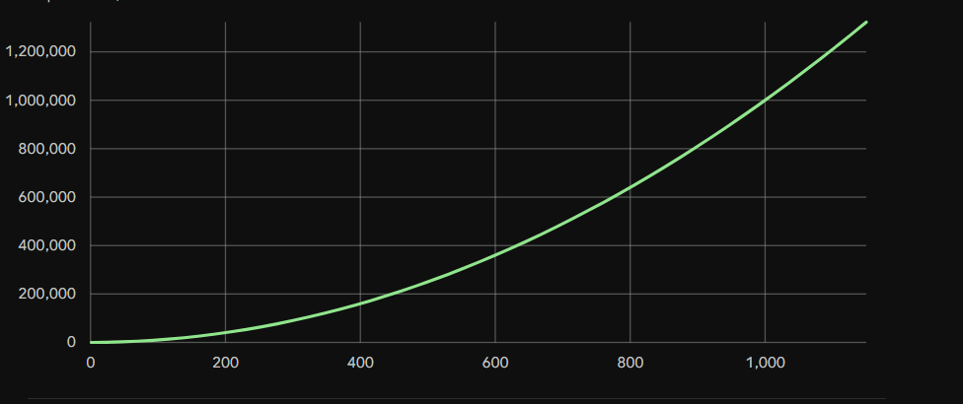

Lab Program 8: Sort a given set of N integer elements using Heap Sort technique and compute its time taken.

Code:
#include <stdio.h>

// Function to swap two elements
void swap(int *a, int *b) {
int temp = *a;
*a = *b;
*b = temp;
}

// Heapify function
void heapify(int arr[], int n, int i) {
int largest = i;
int left = 2 * i + 1;
int right = 2 * i + 2;

// Check left child
if (left < n && arr[left] > arr[largest])
largest = left;

// Check right child
if (right < n && arr[right] > arr[largest])
largest = right;

// Swap and continue heapifying if root is not largest
if (largest != i) {
swap(&arr[i], &arr[largest]);
heapify(arr, n, largest);
}
}

// Heap Sort function
void heapSort(int arr[], int n) {

// Build max heap
for (int i = n / 2 - 1; i >= 0; i--)
heapify(arr, n, i);

// Extract elements one by one
for (int i = n - 1; i > 0; i--) {

// Move current root to end
swap(&arr[0], &arr[i]);

// Heapify reduced heap
heapify(arr, i, 0);
}
}

// Function to print array
void printArray(int arr[], int n) {
for (int i = 0; i < n; i++)
printf("%d ", arr[i]);

printf("\n");
}

// Main function
int main() {
int n;

// Input size of array
printf("Enter number of elements: ");
scanf("%d", &n);

int arr[n];

// Input array elements
printf("Enter %d elements:\n", n);

for (int i = 0; i < n; i++) {
scanf("%d", &arr[i]);
}

printf("Original array:\n");
printArray(arr, n);

// Perform heap sort
heapSort(arr, n);

printf("Sorted array:\n");
printArray(arr, n);

return 0;
}

Output:
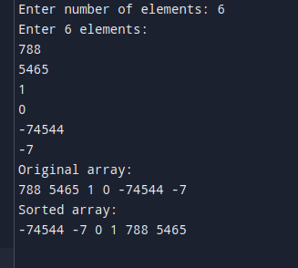

Lab Program 9:

Implement 0/1 Knapsack problem using dynamic programming.

Code:
#include <stdio.h>
// Helper function to find the maximum of two integers
int max(int a, int b) {
return (a > b) ? a : b;
}
// Function to solve the 0/1 Knapsack problem using dynamic programming
void Knapsack(int M, int wt[], int val[], int n) {
int dp[101][101];
for (int i = 0; i <= n; i++) {
for (int w = 0; w <= M; w++) {
if (i == 0 || w == 0) {
dp[i][w] = 0;
}
else if (wt[i - 1] <= w) {
dp[i][w] = max(val[i - 1] + dp[i - 1][w - wt[i - 1]], dp[i - 1][w]);
}
else {
dp[i][w] = dp[i - 1][w];
}
}
}
printf("Maximum value = %d\n", dp[n][M]);
}
int main() {
int n, M;
printf("Enter no.of items: ");
scanf("%d", &n);
printf("Enter Knapsack capacity: ");
scanf("%d", &M);

int wt[n], val[n];

printf("Enter weights:\n");
for (int i = 0; i < n; i++) {
scanf("%d", &wt[i]);
}

printf("Enter values:\n");
for (int i = 0; i < n; i++) {
scanf("%d", &val[i]);
}

Knapsack(M, wt, val, n);

return 0;
}

Output:
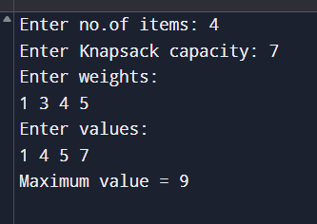

LEETCODE: 956 Tallest Billboard

Code:
#include <stdlib.h>
#include <string.h>

int max(int a, int b) {
return a > b ? a : b;
}

int tallestBillboard(int* rods, int rodsSize) {
int sum = 0;
for (int i = 0; i < rodsSize; i++) {
sum += rods[i];
}

int *dp = (int *)malloc(sizeof(int) * (sum + 1));
for (int i = 0; i <= sum; i++) dp[i] = -1;

dp[0] = 0;

for (int i = 0; i < rodsSize; i++) {
int r = rods[i];
int *temp = (int *)malloc(sizeof(int) * (sum + 1));
memcpy(temp, dp, sizeof(int) * (sum + 1));

for (int diff = 0; diff <= sum - r; diff++) {
if (temp[diff] < 0) continue;

// Add to taller side
dp[diff + r] = max(dp[diff + r], temp[diff]);

// Add to shorter side
int newDiff = abs(diff - r);
dp[newDiff] = max(dp[newDiff], temp[diff] + (diff < r ? diff : r));
}

free(temp);
}

int result = dp[0];
free(dp);
return result;
}

Output:


Lab Program 10:

Implement All Pair Shortest paths problem using Floyd’s algorithm.

Code:
#include <stdio.h>
#define INF 999

int main() {
int n;
printf("Enter the no of vertices: ");
scanf("%d", &n);

int dist[n][n];
printf("Enter cost adjacency matrix:\n");
for (int i = 0; i < n; i++) {
for (int j = 0; j < n; j++) {
scanf("%d", &dist[i][j]);
// If there is no edge between two distinct vertices, set it to INF
if (dist[i][j] == 0 && i != j) {
dist[i][j] = INF;
}
}
}

// Core Floyd-Warshall Algorithm logic
for (int k = 0; k < n; k++) {
for (int i = 0; i < n; i++) {
for (int j = 0; j < n; j++) {
if (dist[i][k] + dist[k][j] < dist[i][j]) {
dist[i][j] = dist[i][k] + dist[k][j];
}
}
}
}

printf("Shortest path matrix:\n");
for (int i = 0; i < n; i++) {
for (int j = 0; j < n; j++) {
if (dist[i][j] == INF) {
printf("INF ");
} else {
printf("%d ", dist[i][j]);
}
}
printf("\n");
}

return 0;
}

Output:
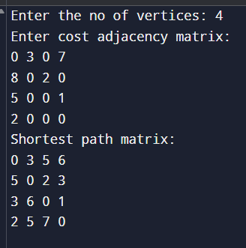

LEETCODE: 1976 Number of Ways To Arrive At a Destination

Code:
#include <limits.h>

#define MOD 1000000007
typedef long long ll;

int countPaths(int n, int** roads, int roadsSize, int* roadsColSize) {

ll mat[201][201];

// initialize matrix
for (int i = 0; i < n; i++) {
for (int j = 0; j < n; j++) {
mat[i][j] = LLONG_MAX;
}
}

// fill roads
for (int i = 0; i < roadsSize; i++) {
int u = roads[i][0];
int v = roads[i][1];
int w = roads[i][2];
mat[u][v] = w;
mat[v][u] = w;
}

ll dist[201];
int ways[201];
int vis[201];

for (int i = 0; i < n; i++) {
dist[i] = LLONG_MAX;
ways[i] = 0;
vis[i] = 0;
}

dist[0] = 0;
ways[0] = 1;

for (int i = 0; i < n; i++) {

int u = -1;

// find min distance node
for (int j = 0; j < n; j++) {
if (!vis[j] && (u == -1 || dist[j] < dist[u])) {
u = j;
}
}

vis[u] = 1;

// relax edges
for (int v = 0; v < n; v++) {
if (mat[u][v] == LLONG_MAX) continue;

ll nd = dist[u] + mat[u][v];

if (nd < dist[v]) {
dist[v] = nd;
ways[v] = ways[u];
}
else if (nd == dist[v]) {
ways[v] = (ways[v] + ways[u]) % MOD;
}
}
}

return ways[n - 1];
}

Output:
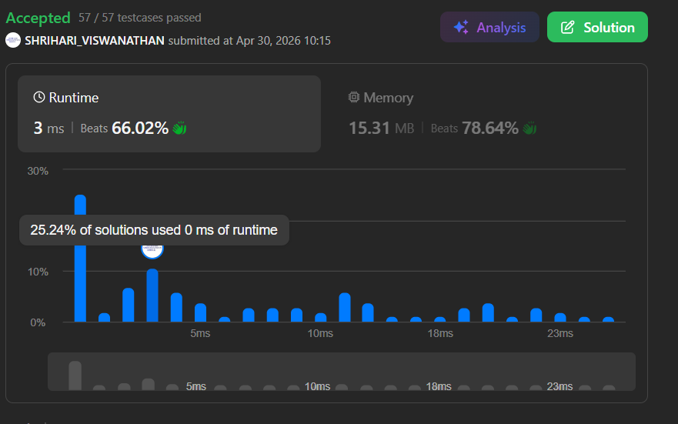

Lab Program 11:

Find Minimum Cost Spanning Tree of a given undirected graph using Kruskal’s algorithm.

Code:
#include <stdio.h>
#include <stdlib.h>

// Edge structure
typedef struct {
int u, v, w;
} Edge;

// Disjoint Set
int parent[100], rank[100];

// Find with path compression
int find(int x) {
if (parent[x] != x)
parent[x] = find(parent[x]);
return parent[x];
}

// Union by rank
void unite(int a, int b) {
int rootA = find(a);
int rootB = find(b);

if (rootA == rootB) return;

if (rank[rootA] < rank[rootB])
parent[rootA] = rootB;
else if (rank[rootA] > rank[rootB])
parent[rootB] = rootA;
else {
parent[rootB] = rootA;
rank[rootA]++;
}
}

// Sort edges by weight
int cmp(const void *a, const void *b) {
Edge *e1 = (Edge*)a;
Edge *e2 = (Edge*)b;
if (e1->w < e2->w) return -1;
if (e1->w > e2->w) return 1;
return 0;
}

int main() {
int V, E;

printf("Enter number of vertices and edges: ");
scanf("%d %d", &V, &E);

Edge edges[E];

printf("Enter all edges in the format: u v weight\n");
for (int i = 0; i < E; i++) {
scanf("%d %d %d", &edges[i].u, &edges[i].v, &edges[i].w);
}

// Initialize DSU
for (int i = 0; i < V; i++) {
parent[i] = i;
rank[i] = 0;
}

// Sort edges by weight
qsort(edges, E, sizeof(Edge), cmp);

int total = 0, count = 0;

printf("\nEdges in the MST:\n");
for (int i = 0; i < E && count < V - 1; i++) {
if (find(edges[i].u) != find(edges[i].v)) {
unite(edges[i].u, edges[i].v);
printf("%d - %d : %d\n", edges[i].u, edges[i].v, edges[i].w);
total += edges[i].w;
count++;
}
}

printf("Total weight = %d\n", total);
return 0;
}

Output:
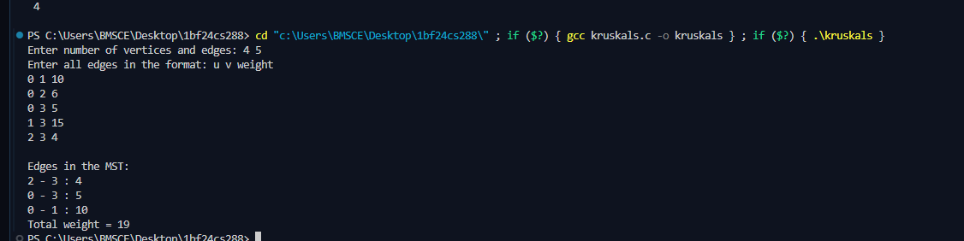

Find Minimum Cost Spanning Tree of a given undirected graph using Prim’s algorithm.

Code:
#include <stdio.h>
#define INF 9999

int main() {
int n;
printf("Enter number of vertices: ");
scanf("%d", &n);

int cost[n][n];

printf("Enter cost adjacency matrix:\n");
for(int i = 0; i < n; i++) {
for(int j = 0; j < n; j++) {
scanf("%d", &cost[i][j]);
if(cost[i][j] == 0)
cost[i][j] = INF; // no edge
}
}

int visited[n];
for(int i = 0; i < n; i++)
visited[i] = 0;

visited[0] = 1; // start from vertex 0

int edges = 0, mincost = 0;

printf("\nEdges in MST:\n");

while(edges < n - 1) {
int min = INF, a = -1, b = -1;

for(int i = 0; i < n; i++) {
if(visited[i]) {
for(int j = 0; j < n; j++) {
if(!visited[j] && cost[i][j] < min) {
min = cost[i][j];
a = i;
b = j;
}
}
}
}

if(a != -1 && b != -1) {
printf("%d - %d : %d\n", a, b, min);
mincost += min;
visited[b] = 1;
edges++;
}
}

printf("Minimum cost = %d\n", mincost);
return 0;
}

Output:
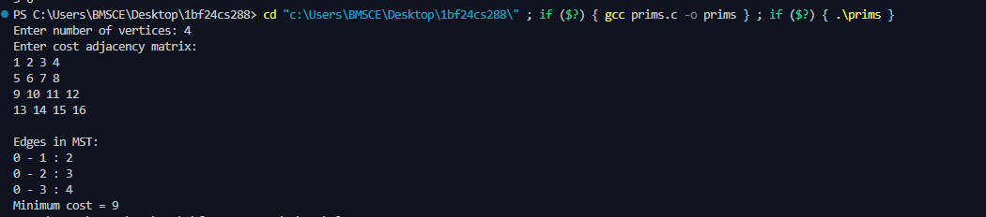

Lab Program 12: Implement fractional knapsack problem using Greedy technique.

Code:
#include <stdio.h>

struct Item {
int profit;
int weight;
float ratio;
};

// Function to sort items based on profit/weight ratio in descending order
void sort(struct Item arr[], int n) {
struct Item temp;
for (int i = 0; i < n - 1; i++) {
for (int j = i + 1; j < n; j++) {
if (arr[i].ratio < arr[j].ratio) {
temp = arr[i];
arr[i] = arr[j];
arr[j] = temp;
}
}
}
}

int main() {
int n;
float capacity;

printf("Enter no. of items: ");
scanf("%d", &n);

printf("Enter capacity of knapsack: ");
scanf("%f", &capacity);

struct Item arr[n];
float sol[n];

// Initialize solution array to 0
for (int i = 0; i < n; i++) {
sol[i] = 0;
}

// Input weights and profits
for (int i = 0; i < n; i++) {
printf("Enter weight of item %d: ", i + 1);
scanf("%d", &arr[i].weight);
printf("Enter profit of item %d: ", i + 1);
scanf("%d", &arr[i].profit);

// Calculate profit-to-weight ratio
arr[i].ratio = (float)arr[i].profit / arr[i].weight;
}

// Sort items by ratio
sort(arr, n);

float total_profit = 0;

// Greedy calculation
for (int i = 0; i < n; i++) {
if (capacity == 0) {
break;
}

if (arr[i].weight <= capacity) {
total_profit += arr[i].profit;
capacity -= arr[i].weight;
sol[i] = 1;
} else {
// Calculate fraction item slice
total_profit += arr[i].profit * ((float)capacity / arr[i].weight);
sol[i] = (float)capacity / arr[i].weight;
capacity = 0;
}
}

printf("Max profit = %f\n", total_profit);

return 0;
}

Output:
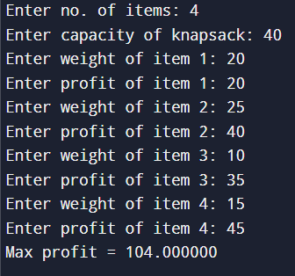

Lab Program 13: From a given vertex in a weighted connected graph, find shortest paths to other vertices using Dijkstra’s algorithm.

Code:
#include <stdio.h>

#define INF 9999

int main() {
int n;

printf("Enter no. of vertices: ");
scanf("%d", &n);

int cost[n][n], dist[n], visited[n];

printf("Enter cost adjacency matrix:\n");
for (int i = 0; i < n; i++) {
for (int j = 0; j < n; j++) {
scanf("%d", &cost[i][j]);
if (cost[i][j] == 0 && i != j) {
cost[i][j] = INF;
}
}
}

int source;
printf("Enter Source vertex: ");
scanf("%d", &source);

// Initialization
for (int i = 0; i < n; i++) {
dist[i] = cost[source][i];
visited[i] = 0;
}

dist[source] = 0;
visited[source] = 1;

// Main Dijkstra's Algorithm loop
for (int count = 1; count < n; count++) {
int min = INF;
int next = -1;

// Find the unvisited vertex with the minimum distance
for (int i = 0; i < n; i++) {
if (!visited[i] && dist[i] < min) {
min = dist[i];
next = i;
}
}

// Mark the selected vertex as visited (Added to fix the logic)
if (next != -1) {
visited[next] = 1;

// Update the distance of the neighboring vertices
for (int i = 0; i < n; i++) {
if (!visited[i] && (min + cost[next][i] < dist[i])) {
dist[i] = min + cost[next][i];
}
}
}
}

// Printing the output
printf("\nShortest distance from source\n");
for (int i = 0; i < n; i++) {
printf("%d -> %d = %d\n", source, i, dist[i]);
}

return 0;
}

Output:
